March 2023

Dear Customer,

I am writing to let you know that we are planning to carry out Pre-surface dressing repairs work in your local area.

Where is the work?
We will be undertaking this work with a road closure of B4386 WINSLEY S SHROP BDY-SHREWS RD to WESTBURY. See map below. Please note access/egress for properties within the closure will be maintained when safe to do so.

When will this work take place?
This work will take from Wednesday 14 February to Wednesday 21 February during the day between 9 30am to 4pm. No weekend working.

Please note that all our planned roadworks are subject to change due to weather conditions or unforeseen circumstances. Any changes will be displayed on the yellow advanced warning signs and on https://one.network/

How will this affect traffic?
Signs will be erected in the road before starting the work and the work will be completed as quickly as possible. A signed diversion route will be in place as per map below.

Note diversion route maintains B road status – your vehicle classification may allow you to use a shorter route of lower road classification.

Will there be access to my property/business?
Yes, if you are looking to access a property or business, we will provide access for you.

We will have staff on site who are able to assist with access. Our priority is to keep you and our staff safe, this means that there may be a bit of a wait while we make the site safe for you to travel through the closure or direct you to another entry point.

During the work access to the works area will be restricted to:
- Essential highway personnel
- Local residents who live and reside within the road closure
- Businesses located within the closure (if applicable)
- Pedestrians, dismounted cyclists and equestrians
- Emergency service vehicles

Where is the work?

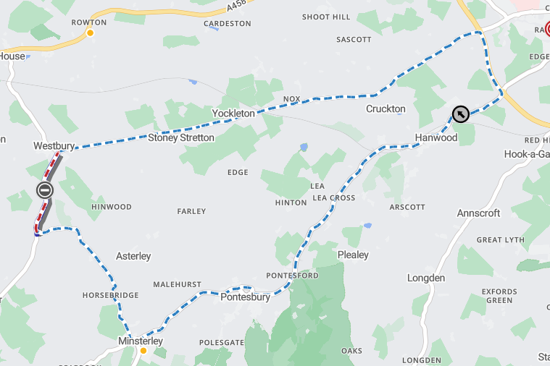
Closure
Diversion
How can you help us?
It would be appreciated if you could ensure vehicles are not parked on the road during the day whilst the work is in progress. Please be mindful that we can only provide access for properties/businesses within the work area. Should this cause any problems or concerns then please do not hesitate to call the number below or alternatively speak to our team on site to allow arrangements to be put in place.

Find out more
Should you have any queries or wish to discuss any of the above please do not hesitate to contact Shropshire Council’s Highways Customer Services Centre on 0345 6789006. Full details of work to be carried out in your area can be found on https://one.network

Kind regards

Kier Highways on behalf of
Shropshire Highways

